**Experiment 2.3**

# Name: Sahil Hansa UID:21BCS7179

**Section/Group:21BCS_CC_645 B Branch: CSE**

# Semester:6th Date: 6/3/2024

**Subject Name:-Cloud Computing and Distributed System Lab Subject Code:21CSP-378**

**Aim**: Discover a method for initiating a virtual machine using the TryStack (Online Open Stack Demo Version).

**Objective:** To Find a procedure to launch virtual machine using trystack.

**Procedure:** OpenStack is an open-source software cloud computing platform. OpenStack is primarily used for deploying an infrastructure as a service (IaaS) solution like Amazon Web Service (AWS). In other words, you can make your own AWS by using OpenStack. If you want to try out OpenStack, TryStack is theeasiest and free way to do it. In order to try OpenStack in TryStack, you must register yourself by joining TryStack Facebook Group. The acceptance of group needs a couple days because it’s approved manually. After you have been accepted in the TryStack Group, youcan log in TryStack.

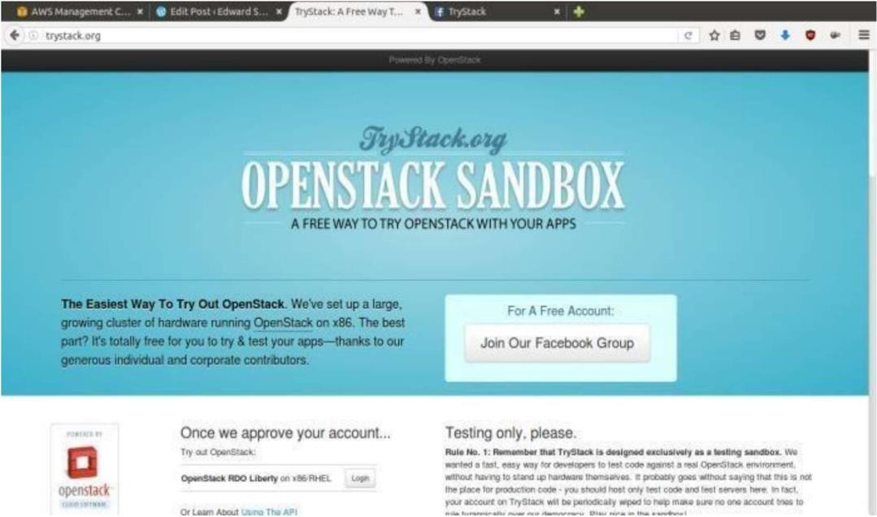

TryStack.org Homepage

I assume that you already join to the Facebook Group and login to the dashboard. After you log in to the TryStack, you will see the Compute Dashboard like-

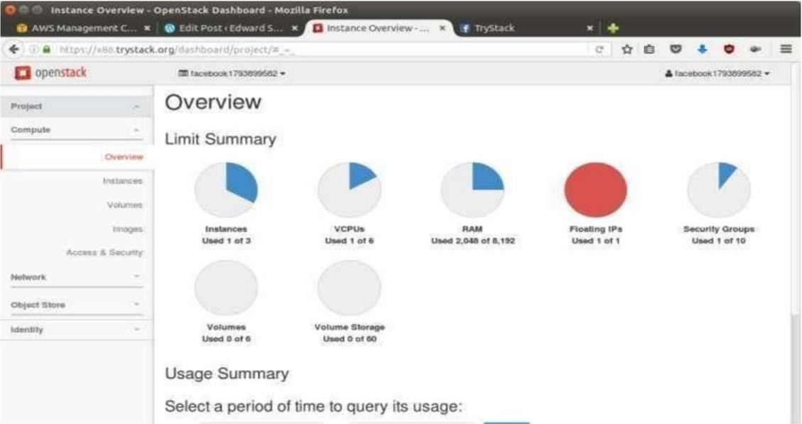

OpenStack Compute Dashboard

In this post, I will show you how to run an OpenStack instance. The instance willbe accessible through the internet (have a public IP address). The final topology will like:

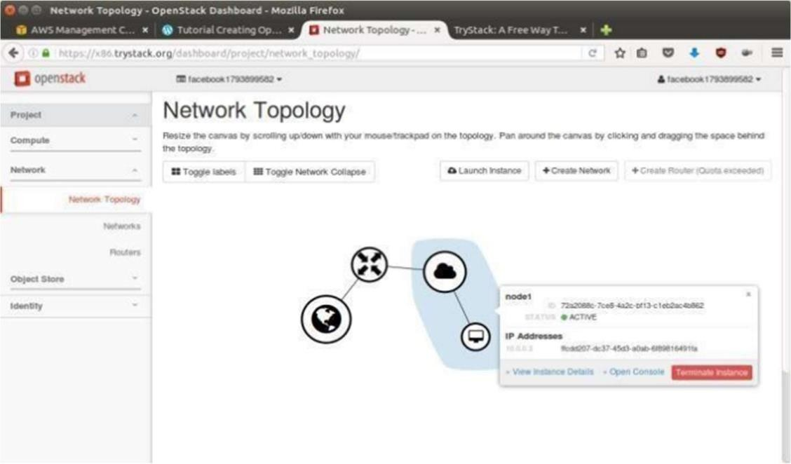

Network topology

As you see from the image above, the instance will be connected to a local network and the local network will be connected to internet.

Step 1: Create Network

Network? Yes, the network in here is our own local network. So, your instanceswill be not mixed up with the others. You can imagine this as your own LAN (Local Area Network) in the cloud.

* Go to Network > Networks and then click Create Network.
* In Network tab, fill Network Name for example internal and then click Next.
* In Subnet tab,
  + Fill Network Address with appropriate CIDR, for example 192.168.1.0/24. Use private network CIDR block as the best practice.
  + Select IP Version with appropriate IP version, in this case IPv4.
  + Click Next.
  + In Subnet Details tab, fill DNS Name Servers with 8.8.8.8 (GoogleDNS) and then click Create.

Step 2: Create Instance

Now, we will create an instance. The instance is a virtual machine in the cloud,like AWS EC2. You need the instance to connect to the network that we just created in the previous step.

* Go to Compute > Instances and then click Launch Instance.
* In Details tab,
  + Fill Instance Name, for example Ubuntu 1.
  + Select Flavor, for example m1.medium.
  + Fill Instance Count with 1.
  + Select Instance Boot Source with Boot from Image.
  + Select Image Name with Ubuntu 14.04 amd64 (243.7 MB) if you want install Ubuntu 14.04 in your virtual machine.
* In Access & Security tab,
  + Click [+] button of Key Pair to import key pair. This key pair is a public and private key that we will use to connect to the instance from our machine.
  + In Import Key Pair dialog,
  + Fill Key Pair Name with your machine name (for example Edward-Key).
  + Fill Public Key with your SSH public key (usually is in ~/.ssh/id_rsa.pub). See description in Import Key Pair dialog box for more information. If you are using Windows, you can use Puttygen to generate key pair.
  + Click Import key pair.
  + In Security Groups, mark/check default.
* In Networking tab,
  + In Selected Networks, select network that have been created in Step 1, for example internal.
* Click Launch.
* If you want to create multiple instances, you can repeat step 1-5. I created onemore instance with instance name Ubuntu 2.

Step 3: Create Router

I guess you already know what router is. In the step 1, we created our network, but it is isolated. It doesn’t connect to the internet. To make our network has an internet connection, we need a router that running as the gateway to the internet.

* Go to Network > Routers and then click Create Router.
* Fill Router Name for example router1 and then click Create router.
* Click on your router name link, for example router1, Router Details page
* Click Set Gateway button in upper right:
  + Select External networks with external.
  + Then OK.
* Click Add Interface button.
* Select Subnet with the network that you have been created in Step 1.
* Click Add interface.
* Go to Network > Network Topology. You will see the network topology. In theexample, there are two network, i.e. external and internal, those are bridged by a router. There are instances those are joined to internal network.

Step 4: Configure Floating IP Address

Floating IP address is public IP address. It makes your instance is accessible from the internet. When you launch your instance, the instance will have a private network IP, but no public IP. In OpenStack, the public Ips is collected in a pool and managed by admin (in our case is TryStack). You need to request a public (floating) IP address to be assigned to your instance.

* Go to Compute > Instance.
* In one of your instances, click More > Associate Floating IP.
* In IP Address, click Plus [+].
* Select Pool to external and then click Allocate IP.
* Click Associate.
* Now you will get a public IP, e.g. 8.21.28.120, for your instance.

Step 5: Configure Access & Security OpenStack has a feature like a firewall. It can whitelist/blacklist your in/outconnection. It is called Security Group.

* Go to Compute > Access & Security and then open Security Groups tab.
* In default row, click Manage Rules.
* Click Add Rule, choose ALL ICMP rule to enable ping into your instance, and then click Add.
* Click Add Rule, choose HTTP rule to open HTTP port (port 80), and then click Add.
* Click Add Rule, choose SSH rule to open SSH port (port 22), and then click Add.
* You can open other ports by creating new rules Step 6: SSH to Your Instance

Now, you can SSH your instances to the floating IP address that you got in thestep 4. If you are using Ubuntu image, the SSH user will be ubuntu.

# RESULT:

